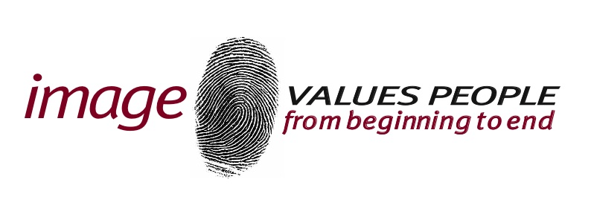

Subject Access
Request Form
IMPORTANT INFORMATION
Image collects, holds, and processes certain personal data about our customers (“data subjects”). As a data subject, you have a legal right, under EU Regulation 2016/679 General Data Protection Regulation (“GDPR”) to find out about our use of your personal data as follows:
- Confirmation that your personal data is being processed by us;
- Access to your personal data;
- How we use your personal data and why;
- Details of any sharing or transfers of your personal data;
- How long we hold your personal data;
- Details of your rights under the GDPR including, but not limited to, your rights to withdraw your consent to our use of your personal data at any time and/or to object to our processing of it.

No fee is payable under normal circumstances. We reserve the right to charge a reasonable fee for requests that are manifestly unfounded, excessive, or repetitive. Such charges will be based only on the administrative cost that we will incur in order to respond.

Please complete the required information overleaf and return it to us by email AND/OR by post addressed to: Pat Anders
Data Protection Contact Unit 4 & 5 Wesley Centre
Royce Road
M15 5BP
You do not have to use this form and may instead write to us using the same contact details.

After receiving your subject access request, we may contact you to request additional supporting information and/or proof of your identity. This helps us to safeguard your privacy and personal data.
We will respond to all subject access requests within one month of receipt and will aim to provide all required information to you within the same period. If we require more information from you, or if your request is unusually complicated, we may require more time and will inform you accordingly.

If you are making a subject access request on someone else’s behalf, please contact Pat Anders, Data Protection Contact at Unit 4 & 5 Wesley Centre, or by telephone on 0161 273 8090 before making your request.
SUBJECT ACCESS REQUEST FORM

Your Details

Title:
Forename(s):
Surname:
Address:
Telephone Number:
Email Address:

Information Being Requested

Please provide specific details (along with any relevant dates) of the information being requested and any additional information that may help us to locate your personal data and to confirm your identity.
By completing this form, you are making a subject access request under the GDPR for personal data collected, processed, and held about you by us that you are entitled to receive.
Declaration

By signing below, you confirm that you are the data subject named in this Subject Access Request Form. You warrant that you are the individual named and will fully indemnify Image for all losses and expenses incurred if you are not. We cannot accept requests in respect of your personal data from anyone else, including members of your family.

Name:
Signature:
Date:

